Created bucket with 2 folders
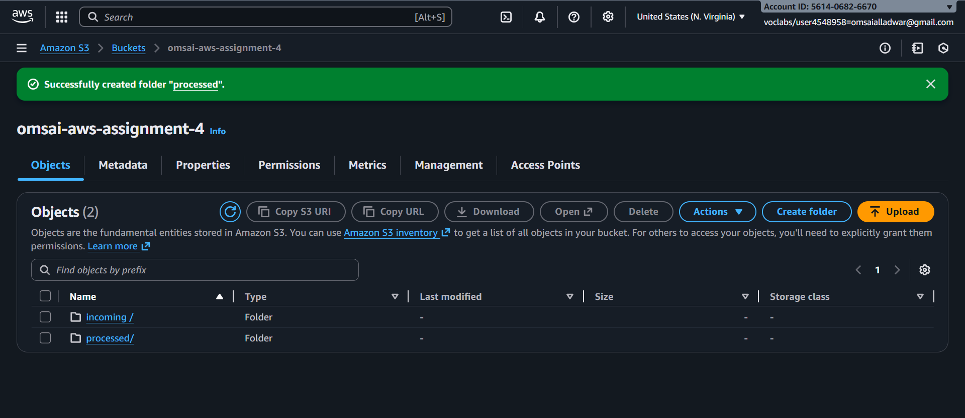

Create a lambda function
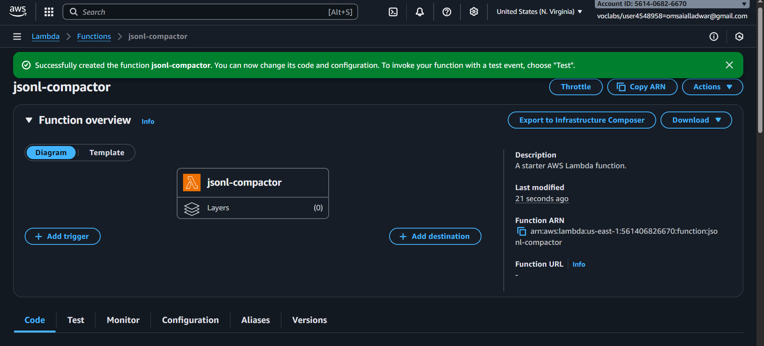

Added code to the function and deployed

import json
import gzip
import boto3
import os
import io
import urllib.parse

s3 = boto3.client("s3")

def lambda_handler(event, context):
rec = event['Records'][0]
bucket = rec['s3']['bucket']['name']

# Decode key to fix + and %2F issues
key = urllib.parse.unquote_plus(rec['s3']['object']['key'])
print("Triggered for key:", key)

# Process only .jsonl files
if not key.lower().endswith(".jsonl"):
print("Not a JSONL file, skipping")
return {"status": "ignored", "key": key}

# Read input file content
resp = s3.get_object(Bucket=bucket, Key=key)
body = resp['Body'].read().decode("utf-8")

valid_lines = []

# Validate JSON per line
for line in body.splitlines():
line = line.strip()
if not line:
continue
try:
json.loads(line)
valid_lines.append(line)
except Exception as e:
print("Invalid JSON skipped:", line)
continue

cleaned = "\n".join(valid_lines)

# Output file path: processed/<filename>.gz
base = os.path.basename(key)
out_key = f"processed/{base}.gz"

# Compress output
buf = io.BytesIO()
with gzip.GzipFile(fileobj=buf, mode="wb") as f:
f.write(cleaned.encode("utf-8"))

# Upload to S3
s3.put_object(Bucket=bucket, Key=out_key, Body=buf.getvalue())

print(f"✅ Done. Wrote {len(valid_lines)} valid lines to {out_key}")

return {
"status": "ok",
"input": key,
"output": out_key,
"lines_in": len(body.splitlines()),
"lines_out": len(valid_lines)
}
added event trigger to s3
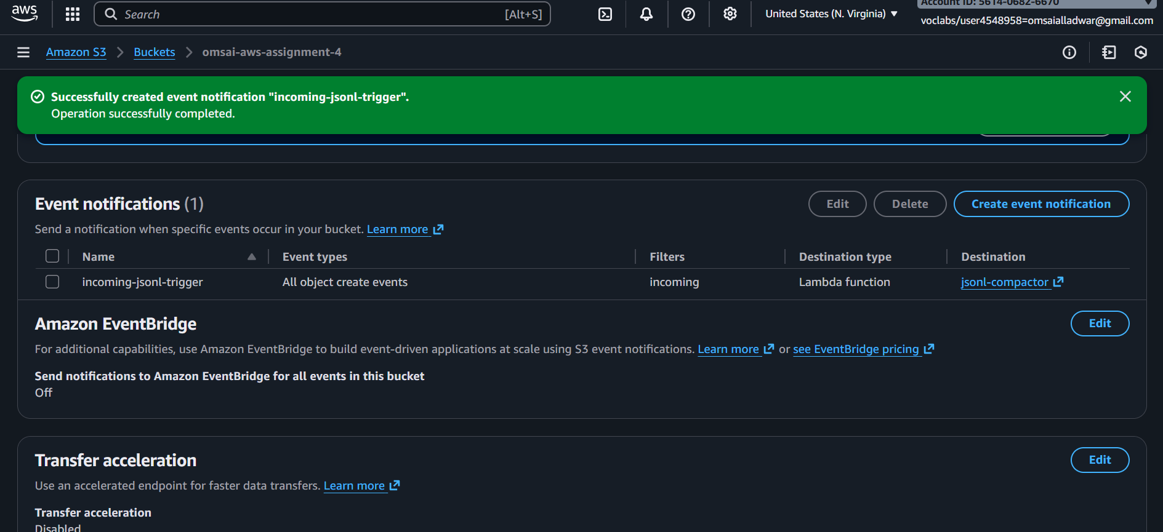

Added jsonl file in incoming folder of bucket
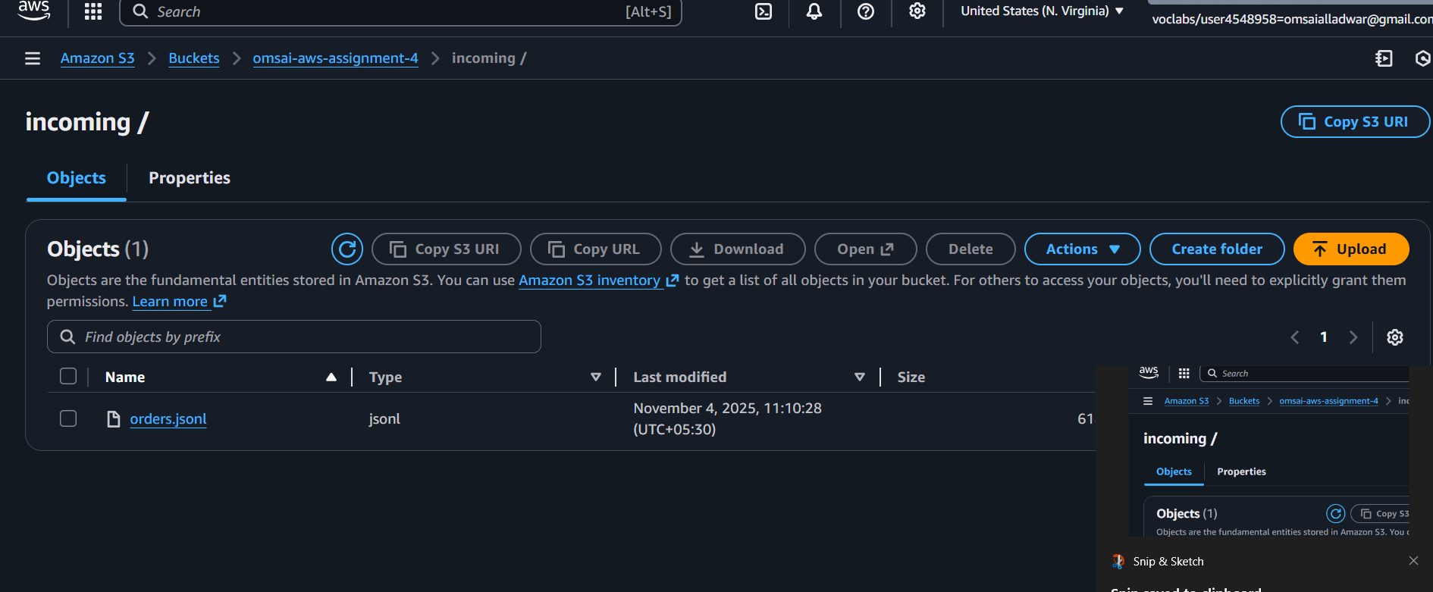

File got added in processed folder
